NAME :P.SASI KUMAR

REG NO :192210030

PRE MODEL EXAM

3.QUESTION

#include <iostream>

using namespace std;

int main() {

int rows;

int n;

std::cout << "Enter the number of rows: ";

std::cin >> rows;

for (int i = 3; i <= rows; i++) {

for (int j = 3; j <= i; j++) {

std::cout << "|";

}

std::cout << std::endl;

}

return 0;

}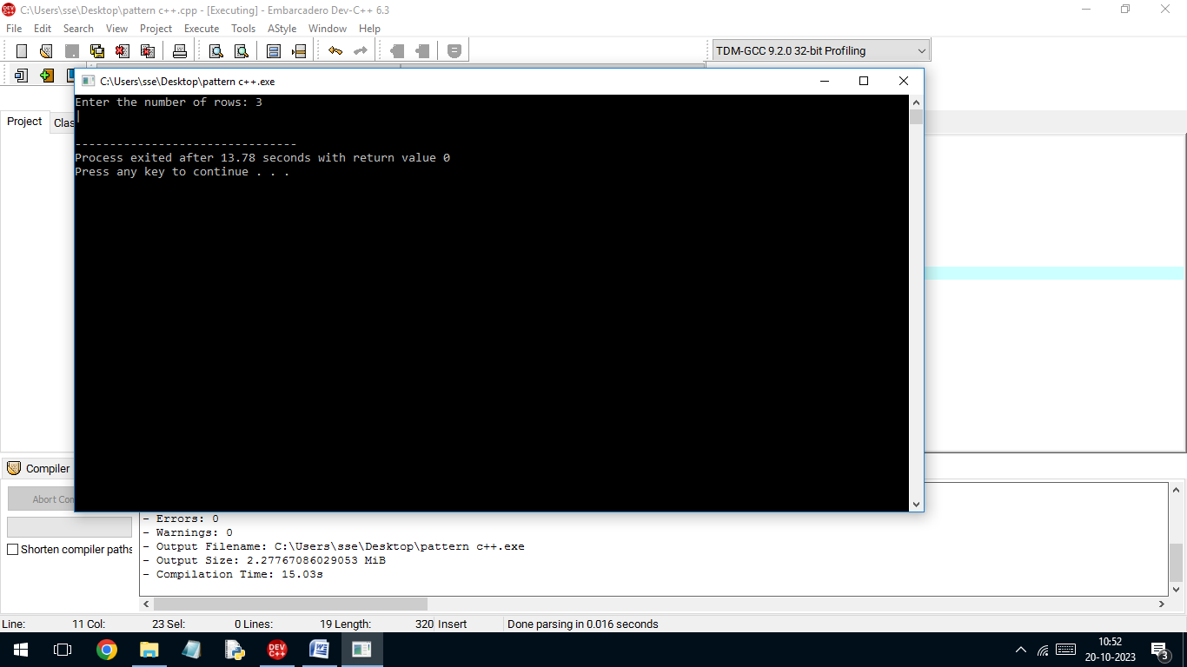4

QUESTION

#include<iostream>

using namespace std;

class vehicle{

public:

char make[10];

char model[10];

int year;

void read(){

cin>>make>>model>>year;

}

void display(){

cout<<"name:"<<make<<endl;

cout<<"model"<<model<<endl;

cout<<"year"<<year<<endl;

}

};

class car:public vehicle{

public:

int capacity;

char ft{10};

void read(){

vehicle::read();

cin>>capacity>>ft;

}

void display(){

vehicle::display();

cout<<"capacity:"<<capacity<<endl;

cout<<"ft:"<<ft<<endl;

}

};

class truck:public vehicle{

public:

int plc;

int tc;

void read(){

vehicle::read();

cin>>plc>>tc;

}

void display(){

vehicle::display();

cout<<"plc"<<endl;

cout<<"tc"<<endl;

}

};

int main(){

car c;

truck t;

c.read();

c.display();

t.read();

t.display();

return 0;

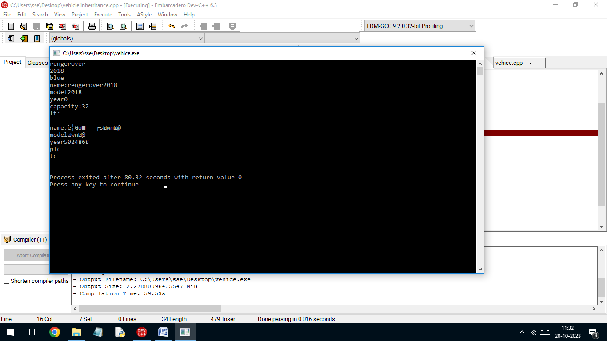

1

QUESTION

#include <iostream>

using namespace std;

class Rectangle {

private:

double length;

double width;

public:

Rectangle(double l,double w) :

length(l), width(w) {}

calculateArea() {

return length \* width;

}

calculatePerimeter() {0;

return 2 \* (length + width);

}

};

int main() {

double length,double width ;

std::cout << "Enter the length of the rectangle: ";

std::cin >> length;

std::cout << "Enter the width of the rectangle: ";

std::cin >> width;

Rectangle myRectangle(length, width);

std::cout << "Area of the rectangle: " << myRectangle.calculateArea() << std::endl;

std::cout << "Perimeter of the rectangle: " << myRectangle.calculatePerimeter() << std::endl;

return 0;

}

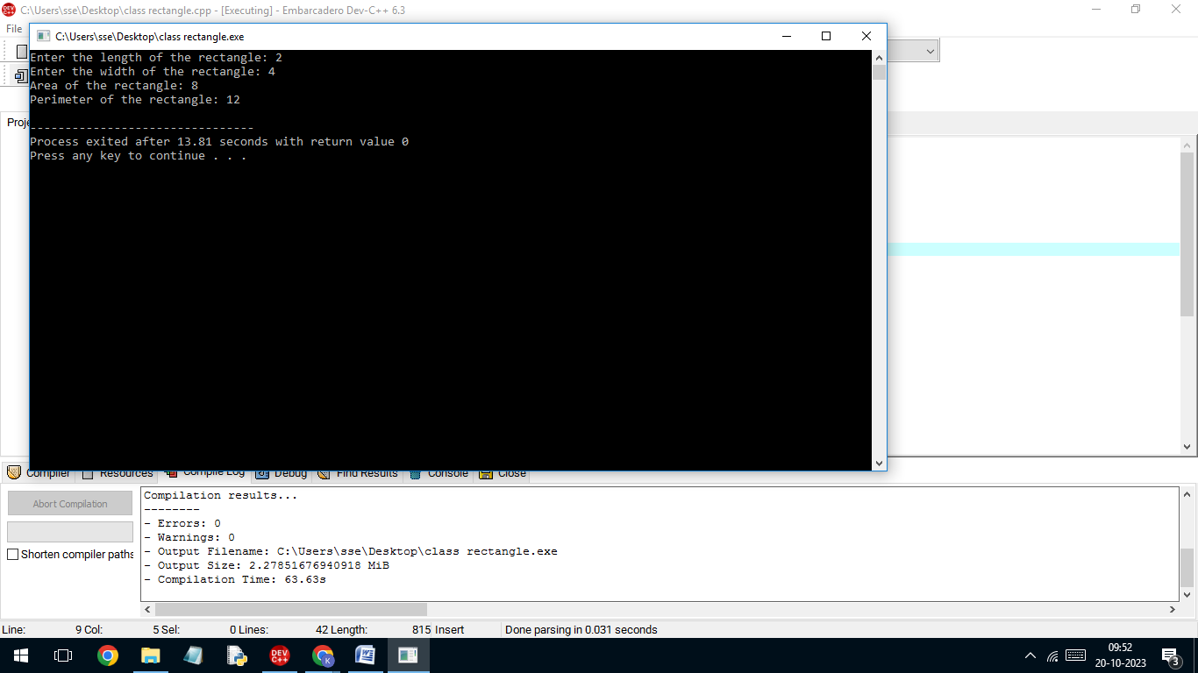

2

QUESTION

#include <iostream>

using namespace std;

class Rectangle {

private:

double length;

double height;

public:

Rectangle(double l, double h) :

length(l), height(h) {}

void setLength(double l) {

length = l;

}

void setHeight(double h) {

height = h;

}

double getLength() {

return length;

}

double getHeight() {

return height;

}

double calculateArea() {

return length \* height;

}

};

int main() {

Rectangle myRectangle(5.0, 3.0);

double length = myRectangle.getLength();

double height = myRectangle.getHeight();

double area = myRectangle.calculateArea();

std::cout << "Rectangle Length: " << length << std::endl;

std::cout << "Rectangle Height: " << height << std::endl;

std::cout << "Rectangle Area: " << area << std::endl;

return 0;

}

